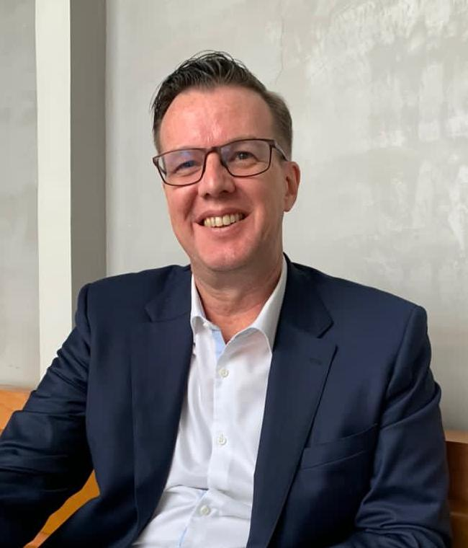

DAVID NOON

January 19th, 2026

To Whom it May Concern

Are you looking for a problem solver, someone who raises the standard of work, effort and output?

I’m very confident that I can help either as an employee or a contractor. My experience ranges from cleaning floors and working in factories to running factories and multi-million-dollar projects and businesses.

I am looking to start a fresh in Australia and would love a chance to work my way up and prove myself in the right organization.

Previous roles have included multiple years in manufacturing, real estate, technology, software and finance.

Most importantly, I am ready to work, and to commit.

Regards,

David Noon
0466 668 659
Davidgnoon@gmail.com

  - Curriculum Vitae of Mr. David G. Noon
Mobile: +61466668659 Email: davidgnoon@gmail.com
Bio and Work History

  - Industries and main areas of experience and expertise:
My experience stretches across a number of industries, roles and business models and across a number of cultures and countries. I have summarized it as follows:
- Infrastructure Development, Infrastructure Finance. Over 17 years of experience.
(Projects from 5 million to ~ 10 billion dollars). Solar, Wind and Hydro as well as thermal power. More broadly with work on ports, railways, waste to energy and agricultural processing infrastructure. (Between 1995 and 2000, 2008 to 2010 and from 2015 to 2021 and for all of 2025).
- Corporate Education and Training. Approximately 10 years of experience.
As a course designer, trainer and consultant with universities and corporate training providers, throughout Asia. Significant experience and a lead trainer in short duration adult corporate training workshops, consulting projects and related activities. Areas covered include Innovation, Strategy, Risk Management and various business acumen related topics. (From 2011 to 2021 full and part time roles.)

- Software Systems, Technology and Finance Management. Over 21 years of experience.
This includes finance analyst roles, software engineering roles (coding) and roles as Programmer, Consultant, Deputy General Manager, General Manager, Chief Finance Officer. (This covers job roles during the periods between 1984 to 2008 and from 2014 to 2021.)

- Management and Directorships/Leadership experience.
This experience includes roles such as Deputy General Manager, General Manager, Chief Finance Officer, Managing Director and CEO. Such roles were across software development, manufacturing, private equity and infrastructure development. (This covers jobs from 1992 to 1994 and 2000 until 2021).

  - Specialist areas covered:
- Aircraft Maintenance Safety Management Systems Audit
- Human Factors Training and Human Factors Risk Management Training.
- Business innovation, Blue Ocean Strategy and Innovation Training, Consulting and Projects: experience leading workshops and consulting engagements for over 5000 participants over the past 10 years. (Organizations up to 110,000 people). Typically work with the Board and senior leadership teams.
- Risk Management Training and Risk Management over the past 6 years including to PIDG/World Bank and IFC standards and for Aviation industry (recent months).
- 7 years managing compliance and governance for projects to World Bank and PIDG Standards. (Including ESG/Climate, Counter Terrorism Financing and Anti-Money Laundering, Anti-Corruption.)
- Experience in Private Equity and Finance focused on Real Estate, Infrastructure (energy, water and transport) development across asia.
- Experience in Finance Management as Finance Officer, Finance and Business Analyst including securing funding and credit lines from banks and private equity investors.
- Experience with various Computer Systems – ERP systems Implementation, data center and cloud based IT infrastructure and software systems integrations. (Specialising in End User and business process focused systems and supporting infrastructure.)
- Manufacturing – discrete furniture components for indoor and various types of outdoor furniture. Roles in Management as GM/Deputy GM over multiple years and with 3 different companies managing between 50 and 3,500 staff.

  - Work History and Highlights of Recent Years:
At the end of November 2021, I made the move back to Australia for personal/family reasons.

May 2025 – Present. AURORA JML INTERNATIONAL Co., Ltd.
Chief Finance Officer / Vice Chairman
- Responsible for all aspects of finance, deal analysis, budgeting and financial planning Covering approximately 20 billion USD in potential investments.
- Drafting/Review of all legal agreements, contracts and key documents (English and Vietnamese).
- Review and Selection of Investment opportunities (Ports, Power plants, LNG Terminal, High-Speed Railway development, acquisition and developments, Real Estate Projects).
April 2022 – February 2025. Savie Global Pty Ltd
Director
- Responsible for all aspects of operations and business development.
- Led drafting and review of all legal agreements, contracts and key documents.
- Various project support and management tasks for Group business activities including contractor selection and management, manufacturing and logistics.
- Organised and led business development trips to Vietnam with Joint Venture partners.
October 2017- December 2023. Hung Viet Consulting Ltd. (Vietnam)
Lead Consultant, Course Designer and Corporate Trainer (Contract)
- Designed and delivered multi-lingual training programs for various clients in Vietnam.
- Lead long term consulting engagement with Electricity Vietnam executives in business innovation and customer service improvement over 18 months.
- Co-led safety and risk management training for Vietnam Airlines over 2019 to 2021.
- Supporting Consultant in Insurance Audit of Safety Systems for Vietnam Airlines MRO.
January 2017 – December 2021. ADL Infra Capital Myanmar Company Limited (Myanmar).
Managing Director/Lead Developer
- Responsible for day-to-day operations, compliance and governance.
- Liaison with Stakeholders for our donor funded program including InfraCo Asia and UK DFiD.
- Sourcing deals, projects and building relationships across relevant government agencies and development institutions such as IFC, World Bank and ADB.
- Lead Developer of Solar PV hybrid power projects, 54MW gas power project, water treatment and wastewater treatment projects as well as alternative energy and agri-infrastructure deals.
- Lead negotiation on disposal of assets and divestment.
June 2015 – September 2021. Infra Capital Myanmar Pte Ltd. (Singapore);
Director and Lead Developer
- Engaged in infrastructure development in Myanmar with seed funding of USD15 Million.
- Leading compliance, Audit and Governance for the company in line with IFC, World Bank and PIDG standards
November 2014 – November 2021. ADL Infra Capital Myanmar Pte Ltd. and ADL Capital Developments Pte. Ltd. (Singapore);
Principal, Managing Director/Key Developer
- PE Advisor to mid-size enterprises in Myanmar, Vietnam, Singapore and Malaysia.
- Assisting with fundraising and corporate finance activities.
- Co-lead the successful bid to secure a 5 year, USD15 Million contract for developer services in Myanmar with InfraCo Asia Pte Ltd – part of the World Bank’s Private Infrastructure Development Group.
- Lead investor discussions on projects across SE Asia with Green Climate Fund, FHM, CIP, Macquarie, Sumitomo etc.
- Selection and negotiations of transactions on renewable energy projects (mostly Solar and Wind) in Vietnam for overseas investors.
May 2011 – Sept 2014. Blue Ocean Strategy Regional Centre @ UCSI Consulting Sdn Bhd
Senior Consultant (Senior Manager), Strategy & Innovation
- Responsible for delivering training and consulting to clients including Government ministries, Agencies and private companies throughout ASEAN countries.
- Designing and leading consulting projects for various clients in Government, banking industry, Retail/Distribution, F&B, Health and other industries.
- Designing and running Strategy & Innovation programs and leadership development for companies – primarily in Malaysia.
- Coaching/Advisory for Star Media Group, Iskandar Investment Bhd, Dong Nai Technology University and others. Other Clients include Maybank, RHB, Iskandar Regional Development Authority, Faber Group and others.
June 2010 – December 2010. Interbuild Far East Ltd (HK)
Country Manager – Vietnam
- Responsible for quality management, product development and supplier development for the furniture sourcing company.
- Managed a team of QC's throughout Vietnam.
- Managed supplier relationships with over 30 factories.
- Successfully managed development of new products for IKEA and other clients.
March 2010 – June 2010. Khai Vy Corporation. HCMC, Vietnam
Interim Acting General Manager – Turnaround (advisory role).
- Reviewed financing options and liaised with banks, the IFC, securities and finance institutions and investors regarding the groups proposed fund raising activities.
- Met and negotiated with major customers on new season orders.
- Assisted in development of new products with IKEA and Carrefour (indoor range).
- Lead efforts to raise funding and establish an $80 million real estate development (in District 7, HCMC, Vietnam).
- Lead development planning and negotiations and financing activities for a five start resort in Nha Trang.
- Responsible for reorganization of the group: legal structure, operational structure.
- Lead the effort to re-establish the company’s ISO 9002 quality system.
February 2008 – November 2008. Pacific Star Group US$400 million fund. HCMC, Vietnam
Consultant/Advisor – Market Entry and Country Setup
- Advised company on market entry activities, licensing and on potential real estate projects.
- Assisted in various due diligence and planning activities for the fund and potential projects.
- Established the Group Office in Vietnam and secured the license for the Vietnam Company.
- Shutdown the business amid the global financial crisis.
October 2006 – December 2010. Bright Asia Int. Ltd. (HK)
Chief Executive Officer and Chairman
- Advisor to Vietnamese businesses in Finance and Private Equity deals.
- Consultant and Advisor regarding Technology for businesses in Vietnam.
- Advisor to Foreign real estate firms and investment funds on real estate development and company establishment issues.
- Sourcing projects in garment, furnishings and furniture in Vietnam for US clients.
- Developing green energy related products for sale to US and other markets.
April 2004 – January 2007. Vinawood Ltd. HCMC, Vietnam & L.A., USA
Deputy General Director (and Acting Finance Manager)
- Managed day to day operations, finance and customer service activities.
- Assisted in setup of ISO9000 and 'LEAN' management systems.
- Responsible for group wide Information Systems, networks and communications.
- Lead the selection and implementation of an ERP system.
- Arranged bank loans and trade finance facilities for company.
- Developed Internet Strategy for existing and new businesses within the group.
- Responsible for securing financing, and for business expansion initiatives including construction of a new 16,000m2 manufacturing facility in Vietnam.
June 2000 – December 2010. Equasian Ltd, HCMC, Vietnam
Chief Executive Officer and Chairman
- Responsible for all aspects of the company’s development.
- Managed multi-million dollar IT projects from design to delivery throughout Vietnam particularly in the education sector for and on behalf of RMIT University Vietnam and other companies.
Managed Software development team of 20+ on numerous projects including Vietnam.com, and ERP system development.
June 2000 – August 2001. Vietnamdotcom Ltd, HCMC, Vietnam
Founder, Chief Operating Officer and Deputy Chairman
- Responsible for all aspects of the company’s development.
- Developed business plan and vision.
- Carried out ongoing market research in Vietnam and in California.
- Conducted fundraising activities, partnership arrangements.
March 1999 – June 2000. Asia Pacific Group (Fund) (JV with CT&D Corp) HCMC & San Francisco
Consultant (Property Development and Finance)
- Responsible for Vietnam and project research and drafting key portions of the Private Placement Memorandum and in structuring Vietnam investment opportunities for US Fund Investors for the US$250 Million fund.
- Participated in fund marketing road-shows across the USA as in house Vietnam property expert/analyst.
May 1995 – October 1999. CT&D Group/Phu My Hung Corporation, Taiwan & Vietnam
Financial Analyst & Project Manager
- Performed detailed business modeling for group investments of US$650 Million in Vietnam.
- Carried out in house market research in construction materials costing and competitive real estate development activities for senior management and business development.
- Project and Development Manager for early stage real-estate development projects (residential, mixed use, schools) within Saigon South.
- Responsible for RMIT University and other major investment projects within the Saigon South Master plan.
- Played pivotal role in securing early financing package of US$190 million dollars in 1995.
- Managed various aspects of the Saigon South Real Estate Development and assisted in developing an investment fund (US$250 Million Dollars in 1998-1999).
May 1992 – December 1994. Springvale Community Health Centre Melbourne
Finance and Administration Officer/COO - Turnaround
- Accounting and finance management, reporting to CEO and over 20 funding agencies.
- Admin and Centre Management, ordering of supplies, building maintenance.
- Staff rosters, Payroll and all related HR management activities of 55 health professionals.
- Successfully saved the institution from closure/bankruptcy and built a sustainable and profitable operation.

  - Education:
Recent:
MIT/Sloan – Executive Certificate in Strategy & Innovation (October 2014).
Certificate of Achievement: MITx 15.071 The Analytics Edge (MIT Sloan). March - June 2014. (https://verify.edx.org/cert/5a1566ed02b54c259a11fbdd28fc215e)
Various short courses and professional development trainings in technology, software, internet marketing, green energy and project management (PRINCE2 framework).
1988 HBC College. Victoria, Australia. Assoc. Diploma - Arts
1985 Wangaratta Technical College. Victoria, Australia. High School Applied Science Certificate.

  - References:
Chan Han Meng, Partner (Green Tech Investment Fund – China and ADL Capital Group Singapore/Hong Kong) Ph: +6596931880. HMCHAN@adlcap.com.
Randy Chen. Board of Directors Wan Hai Shipping. rrrango@yahoo.com Ph: +886910385285
Ken Atkinson, General Director, Grant Thornton Vietnam. – Written Reference available on request.

Peter Bird, former Managing Director of Rothschild Bank in Asia wrote …
“David has an excellent knowledge of the infrastructure sector in SE Asia. He has excellent commercial judgement, has creative ideas and can bring a project to completion.
In a governance role David has a full understanding of director’s duties. He is a leader, is cool under pressure and exercises independent judgement.”

